|  |  |
| --- | --- |
|  | **Министерство науки и высшего образования Российской Федерации Федеральное государственное бюджетное образовательное учреждение высшего образования**  **«Московский государственный технический университет имени Н.Э. Баумана**  **(национальный исследовательский университет)» (МГТУ им. Н.Э. Баумана)** |

**Факультет «Информатика и системы управления»**

**Кафедра «Системы обработки информации и управления»**

Новицкий Ярослав ИУ5-35Б

Парадигмы и конструкции языков программирования

**ОТЧЁТ ПО**

**Домашнему заданию**

Москва

2023

**Постановка задачи.**

Написать полнофункциональную игру "Flappy Bird" с использованием библиотеки Pygame, обеспечивающую интерактивное управление птицей, генерацию препятствий и подсчет счета игрока.

**Текст программы.**

import pygame  
import random  
  
pygame.init()  
  
clock = pygame.time.Clock()  
fps = 60  
  
screen_width = 864  
screen_height = 936  
  
screen = pygame.display.set_mode((screen_width, screen_height))  
pygame.display.set_caption('Flappy Bird')  
  
#define font  
font = pygame.font.SysFont('Bauhaus 93', 60)  
  
#define colours  
white = (255, 255, 255)  
  
#define game variables  
ground_scroll = 0  
scroll_speed = 4  
flying = False  
game_over = False  
pipe_gap = 150  
pipe_frequency = 1500 #milliseconds  
last_pipe = -pipe_frequency  
score = 0  
pause_time = 0  
stop_time = 0  
pass_pipe = False  
  
  
#load images  
bg = pygame.image.load('img/bg.png')  
ground_img = pygame.image.load('img/ground.png')  
button_img = pygame.image.load('img/restart.png')  
game_over_img = pygame.image.load('img/game_over2.png')  
  
  
def draw_text(text, font, text_col, x, y):  
 img = font.render(text, True, text_col)  
 screen.blit(img, (x, y))  
  
  
def reset_game():  
 pipe_group.empty()  
 flappy.rect.x = 100  
 flappy.rect.y = int(screen_height / 2)  
 score = 0  
 return score  
  
  
  
class Bird(pygame.sprite.Sprite):  
 def __init__(self, x, y):  
 pygame.sprite.Sprite.__init__(self)  
 self.images = []  
 self.index = 0  
 self.counter = 0  
 for num in range(1, 4):  
 img = pygame.image.load(f'img/bird{num}.png')  
 self.images.append(img)  
 self.image = self.images[self.index]  
 self.rect = self.image.get_rect()  
 self.rect.center = [x, y]  
 self.vel = 0  
 self.clicked = False  
  
 def update(self):  
  
 if flying == True:  
 #gravity  
 self.vel += 0.5  
 if self.vel > 8:  
 self.vel = 8  
 if self.rect.bottom < 768:  
 self.rect.y += int(self.vel)  
  
 if game_over == False:  
 #jump  
 if pygame.mouse.get_pressed()[0] == 1 and self.clicked == False:  
 self.clicked = True  
 self.vel = -10  
 if pygame.mouse.get_pressed()[0] == 0:  
 self.clicked = False  
  
 #handle the animation  
 self.counter += 1  
  
 if self.counter > 5:  
 self.counter = 0  
 self.index += 1  
 if self.index >= len(self.images):  
 self.index = 0  
 self.image = self.images[self.index]  
  
 #rotate the bird  
 self.image = pygame.transform.rotate(self.images[self.index], self.vel * -2)  
 else:  
 self.image = pygame.transform.rotate(self.images[self.index], -90)  
  
  
  
class Pipe(pygame.sprite.Sprite):  
 def __init__(self, x, y, position):  
 pygame.sprite.Sprite.__init__(self)  
 self.image = pygame.image.load('img/pipe.png')  
 self.rect = self.image.get_rect()  
 #position 1 is from the top, -1 is from the bottom  
 if position == 1:  
 self.image = pygame.transform.flip(self.image, False, True)  
 self.rect.bottomleft = [x, y - int(pipe_gap / 2)]  
 if position == -1:  
 self.rect.topleft = [x, y + int(pipe_gap / 2)]  
  
 def update(self):  
 self.rect.x -= scroll_speed  
 if self.rect.right < 0:  
 self.kill()  
  
  
class Button():  
 def __init__(self, x, y, image):  
 self.image = image  
 self.rect = self.image.get_rect()  
 self.rect.topleft = (x, y)  
  
 def draw(self):  
  
 action = False  
  
 #get mouse position  
 pos = pygame.mouse.get_pos()  
  
 #check if mouse is over the button  
 if self.rect.collidepoint(pos):  
 if pygame.mouse.get_pressed()[0] == 1:  
 action = True  
  
 #draw button  
 screen.blit(self.image, (self.rect.x, self.rect.y))  
  
 return action  
  
bird_group = pygame.sprite.Group()  
pipe_group = pygame.sprite.Group()  
  
flappy = Bird(100, int(screen_height / 2))  
  
bird_group.add(flappy)  
  
#create restart button instance  
button = Button(screen_width // 2 - 50, screen_height // 2 - 100, button_img)  
  
run = True  
while run:  
  
 clock.tick(fps)  
  
 #draw background  
 screen.blit(bg, (0,0))  
  
 bird_group.draw(screen)  
 bird_group.update()  
 pipe_group.draw(screen)  
  
 #draw the ground  
 screen.blit(ground_img, (ground_scroll, 768))  
  
 #check the score  
 if len(pipe_group) > 0:  
 if bird_group.sprites()[0].rect.left > pipe_group.sprites()[0].rect.left\  
 and bird_group.sprites()[0].rect.right < pipe_group.sprites()[0].rect.right\  
 and pass_pipe == False:  
 pass_pipe = True  
 if pass_pipe == True:  
 if bird_group.sprites()[0].rect.left > pipe_group.sprites()[0].rect.right:  
 score += 1  
 pass_pipe = False  
  
 if flying == True or game_over == True:  
 draw_text(str(score), font, white, int(screen_width / 2), 20)  
  
 #look for collision  
 if pygame.sprite.groupcollide(bird_group, pipe_group, False, False) or flappy.rect.top < 0:  
 game_over = True  
  
 #check if bird has hit the ground  
 if flappy.rect.bottom >= 768:  
 game_over = True  
 flying = False  
  
  
 if game_over == False and flying == True:  
  
 #generate new pipes  
  
 time_now = pygame.time.get_ticks() - pause_time  
 print(time_now)  
 print(last_pipe)  
 if time_now - last_pipe > pipe_frequency:  
 pipe_height = random.randint(-100, 100)  
 btm_pipe = Pipe(screen_width, int(screen_height / 2) + pipe_height, -1)  
 top_pipe = Pipe(screen_width, int(screen_height / 2) + pipe_height, 1)  
 pipe_group.add(btm_pipe)  
 pipe_group.add(top_pipe)  
 last_pipe = time_now  
  
  
 #draw and scroll the ground  
 ground_scroll -= scroll_speed  
 if abs(ground_scroll) > 35:  
 ground_scroll = 0  
  
 pipe_group.update()  
  
  
 #check for game over and reset  
 if game_over == True:  
 screen.blit(game_over_img, (screen_width // 2 - 217, screen_height // 2 - 270))  
 if button.draw() == True :  
 game_over = False  
 score = reset_game()  
 last_pipe = -pipe_frequency  
 score = 0  
 pause_time = 0  
 stop_time = 0  
  
  
 if flying == False and game_over == False:  
 draw_text('Paused', font, white, int(screen_width / 2), 20)  
  
  
 for event in pygame.event.get():  
 if event.type == pygame.QUIT:  
 run = False  
 if event.type == pygame.MOUSEBUTTONDOWN and flying == False and game_over == False:  
 flying = True  
 pause_time += pygame.time.get_ticks() - stop_time  
 if event.type == pygame.KEYDOWN and event.key == pygame.K_SPACE and flying == True and game_over == False:  
 flying = False  
 stop_time = pygame.time.get_ticks()  
  
  
 pygame.display.update()  
  
pygame.quit()

**Экранные формы:**

Старт/пауза

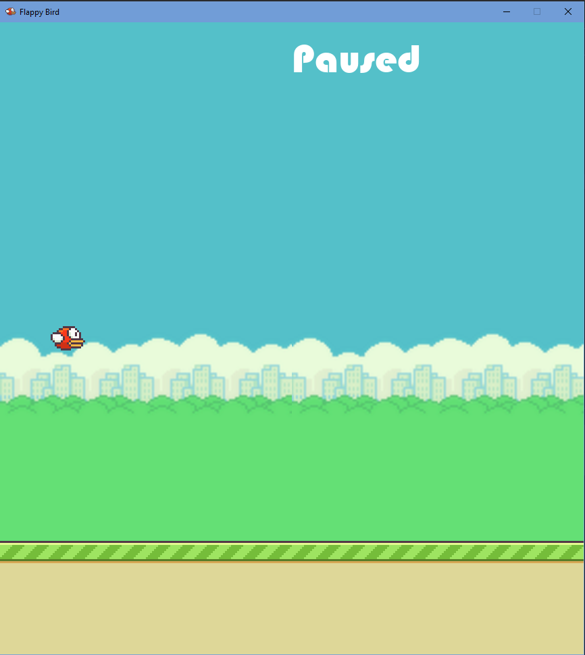

Полёт

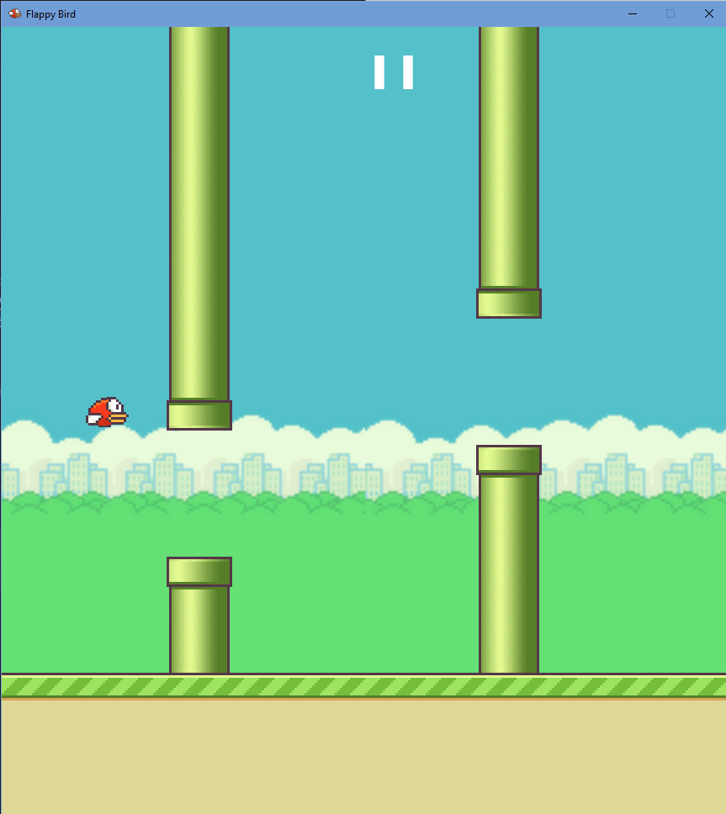

Окончание игры

